System Requirement Specification

UMBC Market

**Client**

Abhay Kashyap

**Team 4**

Cory Ferrier

Sam Leung

Seth Jenkins

Wesley Chiou

Zachary Robinson

UMBC Market

System Requirements Specifications

Table of Contents

1. Introduction

1.1 Purpose of This Document

1.2 Purpose of the Product

1.3 Product Scope

2. Functional Requirements

2.1 Use Case 1

2.2 Use Case 2

2.3 Use Case 3

2.4 Use Case 4

2.5 Use Case 5

2.6 Use Case 6

2.7 Use Case 7

2.8 Use Case 8

3. Non-Functional Requirements

4. User Interface

5. Deliverables

6. Open Issues

Appendix A - Agreement Between Client and Contractor

Appendix B - Team Review Sign-off

Appendix C - Document Contributions

# 1. Introduction

Welcome to the UMBC Market System Requirement Specification. UMBC Market is a platform for UMBC Students to buy, sell, and barter on a student only open market.

## 1.1 Purpose of This Document

This document will explain the features of the UMBC Market web application and it's functions. The document is intended to be referenced by the development team and the client in order to assure client satisfaction.

## 1.2 Purpose of the Product

UMBC Market was designed to provide a closed environment for UMBC Students and Alumni to exchange goods and services, particularly in the context of goods and services relevant to UMBC and their education.

## 1.3 Product Scope

Refer to Figure 1 for a high-level overview of the application scope.

The application consists of the following use cases:

1. Registering for an Account
2. Logging into an Account
3. Listing a Product or Service
4. Editing or Removing a Listing
5. Marking a Listing as Complete
6. Searching for and Viewing Product and Service Listings
7. Contacting a Seller with an Initial Offer
8. Managing Messages

**Figure 1:** High Level Context Diagram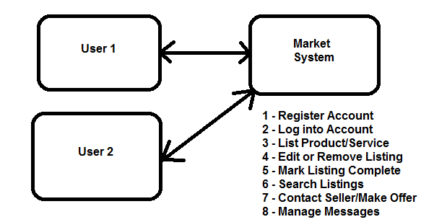

# 2. Functional Requirements

The functional requirements of the UMBC Market application are defined by the following use cases, each corresponding by number to Figure 1, the high-level context diagram. Each use case is presented with its associated diagram below it.

## 2.1 Use Case 1

|  |  |  |
| --- | --- | --- |
| Number | 1 | |
| Name | Registering an Account | |
| Diagram | Figure 2 | |
| Summary | A Market User registers an account with the Market Application. | |
| Priority | 5 | |
| Preconditions |  | |
| Postconditions | Market User has a registered Market account. | |
| Primary Actor | Market User | |
| Secondary Actors | Market Application | |
| Trigger | User initiates registration or prompted when attempting to respond to/create a listing. | |
| Main Scenario | Step | Action |
|  | 1 | User provides registration information. |
|  | 2 | User submits registration information. |
|  | 3 | Market Application validates registration information. |
|  | 4 | Market Application creates account and stores information. |
|  | 5 | Market Application prompts User to log in with new account. |
| Extensions | Step | Branching Action |
|  | 3.a | Registration information is invalid.  3.a.1 User is informed of error and returned to step 1. |
| Open Issues |  | |

**Figure 2:** Use Case 1 Diagram: Register Account

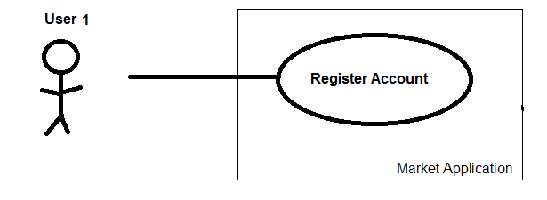

## 2.2 Use Case 2

|  |  |  |
| --- | --- | --- |
| Number | 2 | |
| Name | Logging into an Account. | |
| Diagram | Figure 3 | |
| Summary | A user with an account logs in. | |
| Priority | 5 | |
| Preconditions | User has a Market Account. | |
| Postconditions | User is logged into a Market Account. | |
| Primary Actor | Market User | |
| Secondary Actors | Market Application | |
| Trigger | User attempts to log into account. | |
| Main Scenario | Step | Action |
|  | 1 | User provides login information. |
|  | 2 | Market Application validates login information. |
| Extensions | Step | Branching Action |
|  | 2.a | Validation fails.  2.a.1 User is informed of error and returned to step 1. |
| Open Issues |  | |

**Figure 3:** Use Case 2 Diagram: Log into Account

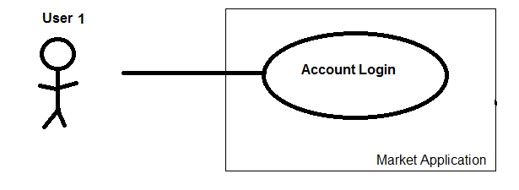

## 2.3 Use Case 3

|  |  |  |
| --- | --- | --- |
| Number | 3 | |
| Name | Listing a Product or Service | |
| Diagram | Figure 4 | |
| Summary | A User creates a listing for a product or service. | |
| Priority | 5 | |
| Preconditions | User is logged into an account. | |
| Postconditions | A listing is created and associated with the User’s account. | |
| Primary Actor | Market User | |
| Secondary Actors | Market Application | |
| Trigger | User attempts to create a listing. | |
| Main Scenario | Step | Action |
|  | 1 | User creates a listing. |
|  | 2 | Application validates listing. |
|  | 3 | Listing is stored in Application database. |
| Extensions | Step | Branching Action |
|  | 2.a | Listing does not meet valid requirements.    2.a.1 User is informed of error and returned to step 1. |
| Open Issues | What constitutes a valid listing? | |

**Figure 4:** Use Case 3 Diagram: List Product or Service

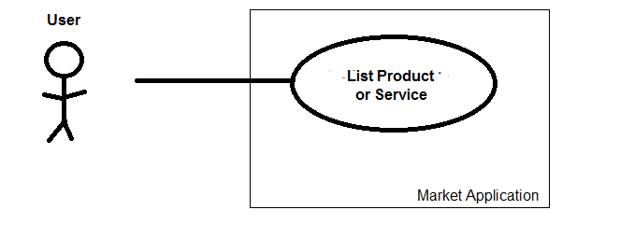

## 2.4 Use Case 4

|  |  |  |
| --- | --- | --- |
| Number | 4 | |
| Name | Editing or Removing a Listing | |
| Diagram | Figure 5 | |
| Summary | A previously created listing is removed from the Market. | |
| Priority | 4 | |
| Preconditions | User is logged into account and a listing exists. | |
| Postconditions | A listing is modified. | |
| Primary Actor | Market User | |
| Secondary Actors | Market Application | |
| Trigger | User attempts to modify a listing. | |
| Main Scenario | Step | Action |
|  | 1 | User chooses a listing to modify. |
|  | 2 | User makes modification to the listing. |
|  | 3 | User submits modifications. |
|  | 4 | Market Application updates listing in database. |
| Extensions | Step | Branching Action |
|  | 3.a | User edits listing but does not remove.  3.a.1 Market Application validates listing.  3.a.2 If invalid, notify User of error and return to step 1. |
| Open Issues |  | |

**Figure 5:** Use Case 4 Diagram: Edit or Remove Listing

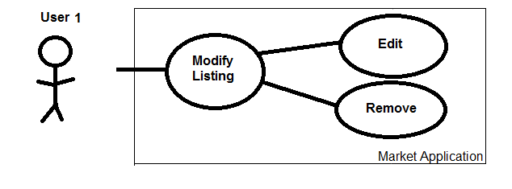

## 2.5 Use Case 5

|  |  |  |
| --- | --- | --- |
| Number | 5 | |
| Name | Marking a Listing Complete | |
| Diagram | Figure 6 | |
| Summary | A Market User updates a listing as completed. | |
| Priority | 4 | |
| Preconditions | User is logged into an account and a listing exists. | |
| Postconditions | Listing is marked complete. | |
| Primary Actor | Market User | |
| Secondary Actors | Market Application | |
| Trigger | User attempts to mark listing as complete. | |
| Main Scenario | Step | Action |
|  | 1 | User chooses to mark a listing as complete. |
|  | 2 | User chooses which listing to mark as complete. |
|  | 3 | Market Application updates listing in database as complete. |
| Extensions | Step | Branching Action |
|  |  |  |
| Open Issues |  | |

**Figure 6:** Use Case 5 Diagram: Mark Listing Complete

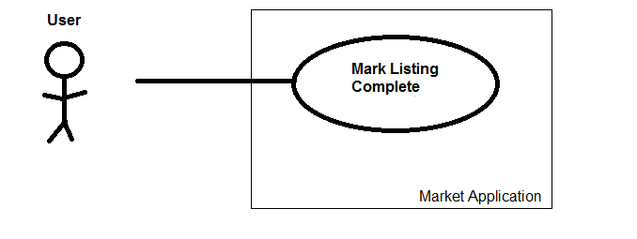

## 2.6 Use Case 6

|  |  |  |
| --- | --- | --- |
| Number | 6 | |
| Name | Searching the Market | |
| Diagram | Figure 7 | |
| Summary | A User searches the Market for listings. | |
| Priority | 3 | |
| Preconditions |  | |
| Postconditions | User is provided a list of related listings. | |
| Primary Actor | Market User | |
| Secondary Actors | Market Application | |
| Trigger | User attempts to search Market. | |
| Main Scenario | Step | Action |
|  | 1 | User provides search terms and specifications. |
|  | 2 | User initiates search. |
|  | 3 | Application populates list from database of related listings. |
|  | 4 | Application displays search results to User. |
| Extensions | Step | Branching Action |
|  |  |  |
| Open Issues |  | |

**Figure 7:** Use Case 6 Diagram: Search Listings

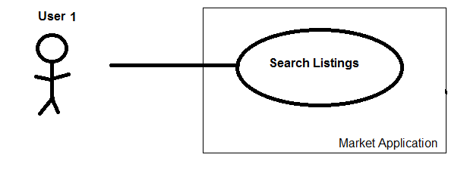

## 2.7 Use Case 7

|  |  |  |
| --- | --- | --- |
| Number | 7 | |
| Name | Contacting a seller with an initial offer. | |
| Diagram | Figure 8 | |
| Summary | A prospective buyer sends a message which is received by the application and distributed to the appropriate seller recipient. | |
| Priority | 5 | |
| Preconditions | User is logged into an account and viewing a listing. | |
| Postconditions | A message is delivered to the proper recipient. | |
| Primary Actor | Market User | |
| Secondary Actors | Market Application, Message Recipient | |
| Trigger | User attempts to contact a seller. | |
| Main Scenario | Step | Action |
|  | 1 | User creates a message. |
|  | 2 | User sends message. |
|  | 3 | Market Application receives message. |
|  | 4 | Market Application distributes message to noted Message Recipient. |
| Extensions | Step | Branching Action |
|  |  |  |
| Open Issues |  | |

**Figure 8:** Use Case 7 Diagram: Contact Seller (Make Initial Offer)

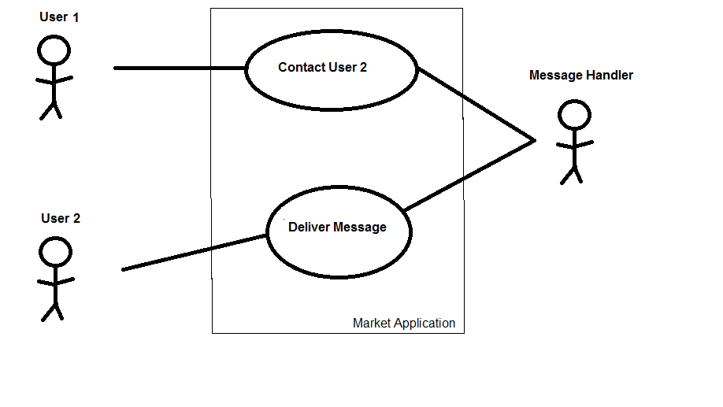

## 2.8 Use Case 8

|  |  |  |
| --- | --- | --- |
| Number | 8 | |
| Name | Managing Messages | |
| Diagram | Figure 9 | |
| Summary | A Market User can view, reply to, and delete messages. | |
| Priority | 5 | |
| Preconditions | User is logged into an account and viewing message box. | |
| Postconditions | User sees, replies to, or deletes message. | |
| Primary Actor | Market User | |
| Secondary Actors | Market Application, Message Recipient | |
| Trigger | User attempts to contact a seller. | |
| Main Scenario | Step | Action |
|  | 1 | User selects a message. |
|  | 2 | User chooses to view, reply to, or delete message. |
| Extensions | Step | Branching Action |
|  | 2.a | User chooses to view message.  2.a.1 Message is displayed to User  2.a.2 User can choose to reply or delete. |
|  | 2.b | User chooses to reply to message.  2.b.1 User writes and submits reply message.  2.b.2 Market Application receives message.  2.b.3 Market Application distributes message to recipient. |
|  | 2.c | User chooses to delete message.    2.c.1 Message is removed from User’s box. |
| Open Issues |  | |

**Figure 9:** Use Case 8 Diagram: Manage Messages

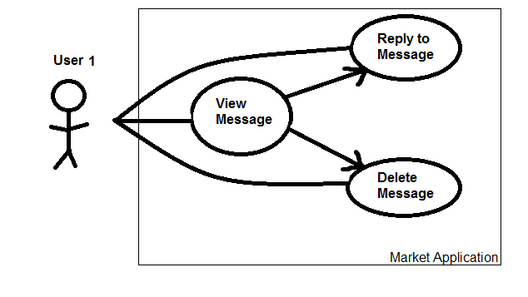

# 3. Non-Functional Requirements

The following non-functional requirements will be fulfilled with increasing focus proportional to the associated priority level. A priority level of 5 denotes the highest priority, while a priority level of 1 denotes the lowest. the lowest. Priority was determined by the effect of the requirement on the overall success of the application.

|  |  |  |
| --- | --- | --- |
| Number | Requirement | Priority |
| 1 | Personal and Account information shall be secure. | 5 |
| 2 | Listings shall be secure. | 5 |
| 3 | Messages shall be passed securely. | 5 |
| 4 | Search results shall be generated quickly. | 4 |
| 5 | Listing posts, edits, and removals shall take effect quickly. | 4 |
| 6 | Application shall be user-friendly. | 4 |
| 7 | Application shall be stable. | 4 |
| 8 | Application code shall be well documented. | 3 |
| 9 | Application shall not lose functionality on mobile devices. | 2 |
| 10 | Application shall be easily maintained. | 2 |

# 

# 4. User Interface

See “User Interface Design Document for UMBC Market.”

# 5. Deliverables

The following deliverables will be finalized and submitted by the specified date in the specified formats:

|  |  |  |
| --- | --- | --- |
| Deliverable | Format | Date |
| System Requirements Specification | Hard Copy  Electronic | 10/06/16 |
| System Design Document | Hard Copy  Electronic | 11/03/16 |
| User Interface Design Document | Hard Copy  Electronic | 11/03/16 |
| User Manual | Hard Copy  Electronic | TBD |
| Administrator Manual | Hard Copy  Electronic | TBD |
| Application Source Code | Electronic | TBD |
| Executable Application | Electronic | TBD |
| Additional Materials used in Application Execution | Electronic | TBD |

# 6. Open Issues

The following issues will be addressed:

1. Identifying what constitutes a valid Market listing.

* Predicted Resolution Date: 10/20/16

# Appendix A - Agreement Between Client and Contractor

The client and contracted team members have come to an agreement on the scope and functionality of the UMBC Market Application to be created. The scope and functionality is detailed clearly through the provided use cases in section two of this document.

If future changes to this document are required, any modifications made will be reviewed by the client and each team member. The client and each team member will then again sign and date the document indicating their approval. When all parties have verified and signed the modified document, the modified document will then become the active working document for the application and the prior instance is deemed void.

**Client**

Name(print): __________________________________________ Date: ____________

Signature: ___________________________________________

Comments: ______________________________________________________________________________________________________________________________________________________________________________________________________________________________________________________________________________________________________________________________________________________________

**Team**

Name(print): __________________________________________ Date: ____________

Signature: ___________________________________________

Name(print): __________________________________________ Date: ____________

Signature: ___________________________________________

Name(print): __________________________________________ Date: ____________

Signature: ___________________________________________

Name(print): __________________________________________ Date: ____________

Signature: ___________________________________________

Name(print): __________________________________________ Date: ____________

Signature: ___________________________________________

# Appendix B - Team Review Sign-off

Each team member has reviewed this document and approves of its content and format. Any minor points of contention are addressed in the comments below.

**Team**

Name(print): __________________________________________ Date: ____________

Signature: ___________________________________________

Comments: ____________________________________________________________________________________________________________________________________________

______________________________________________________________________

Name(print): __________________________________________ Date: ____________

Signature: ___________________________________________

Comments: ____________________________________________________________________________________________________________________________________________

______________________________________________________________________

Name(print): __________________________________________ Date: ____________

Signature: ___________________________________________

Comments: ____________________________________________________________________________________________________________________________________________

______________________________________________________________________

Name(print): __________________________________________ Date: ____________

Signature: ___________________________________________

Comments: ____________________________________________________________________________________________________________________________________________

______________________________________________________________________

Name(print): __________________________________________ Date: ____________

Signature: ___________________________________________

Comments: ____________________________________________________________________________________________________________________________________________

______________________________________________________________________

# Appendix C - Document Contributions

Zachary Robinson drafted the large majority of this document, aided in part by Cory Ferrier who generated an outline and communicated directly with the client.